# **ELECTROSTATICS**

**Electric charge Q**

The strength of particle’s electric interaction with objects around it depends on its electric charge, which can be either **positive** or **negative**. The total electric charge of particle is sum of positive and negative charges.

The structure of atoms can be described in terms of three particles: the positively charged **proton**, the negatively charged **electron** and the uncharged **neutron**.

A proton and an electron have equal and opposite charge. The magnitude of the charge is

***elementary* c*harge e*** 

The charge is **quantized**. Any positive or negative charge can be written as **Q = ± n . e,** where n is integer**.**

The unit of electric charge is *coulomb* (C)

 so 1C = 1As

The electric charge is **conserved**: The net charge of any isolated system cannot change.

Charges with the same electrical sign **repel** each other, and charges with opposite electrical signs **attract** each other.

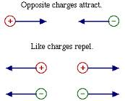

**Coulomb’s law**

Two stationary point charges Q1 and Q2 (with distance of r) exert each other with **electrostatic force**



where k is electrostatic constant

 is permittivity constant 

*  is permittivity of vacuum (8,8542·10-12 *C2/Nm2*)
* is relative permittivity of medium (dielectric material around charge)
* in vacuum and air ( ) 

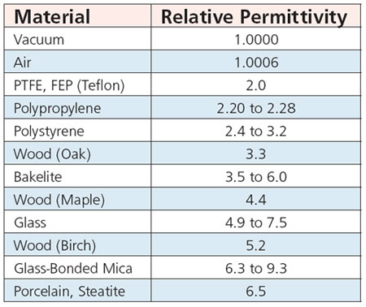

**Electric field E**

The charge generates electric field in the space around it.

The electric field lines are the way to visualize electric field.

The direction of a straight field line gives direction of electric field at that point

The field lines are drawn so that the number of lines per unit area is proportional to the magnitude of electric field

The electric field lines extend away from positive charge and toward negative charge.

### Electric field due to a point charge

Q

q

+



Charge +Q generate electric field, which acting on a positive test charge q with electrostatic force F.

Electric field E at the certain point is defined as the electric force F exerted by the charge distribution on the test particle divided by the charge q.

 

**Calculating the electric field**

Electric field is a **vector** quantity.



If there is a group of point charges, the net field can be calculated with the aid of the principle of superposition. The total electric field is **vector sum** of each electric field.

### Charged objects

Charged objects have an **imbalance of charge** - either more negative electrons than positive protons or vice versa

1. Free charges of charged objects are at the surface of an object
2. There are no electric field inside a charged object
3. Direction of electric field at the surface is perpendicular to the surface

Ratio of electric fields is:



Where is the smallest **radius of curvature**, there is the maximum of the electric field.

**Electric field due to a charged object**

Electric field around charged object is

 , whereis charge per unit area $σ=\frac{Q}{A}$

**Examples:**

1. **Electric field due to a charged metal ball**

on the surface of the ball:

 , where r is radius of ball

on the outside of ball:

, where r is distance from the middle point of ball

inside the ball:



1. **Electric field due to a charged plane**

Electric field around uniformly charged plane is



 ,is charge per unit area $σ=\frac{Q}{A}$



* Direction of the field is perpendicular to

the plane

Two parallel planes with the charge of opposite signs cause a uniform electric field in region between the planes







* outside of planes E = 0



**Potential V ja voltage U**



Uniform electric field affects to the charge with electric force F



When the charge moving in an electric field from position A to position B, work done by electric force is:



**Potential difference** between points A and B (=voltage) is:



This equation is valid only when the electric field is uniform. In common case: 

Potential is scalar, no vector. The unit of potential (and voltage) is V (volt)

**Potential due to a point charge**

Potential difference between two points (voltage) is:



Where rA and rB are distances between point A and B from charge Q

Potential of point which is distance r from charge is:



**Potential due to a charge object**

Conductors have a uniform potential. The potential is the same at every point in object. For example, if the ball made of metal has a radius r, inside of it (and on surface) potential is . The potential of point which is outside of surface calculated same way as potential due to a point charge. (distance r calculated from midpoint of ball)

**Material in the electric field**

Most materials can be classified as one of two types: conductors or insulators.

Charges move easily in conductors, but much less readily in insulators

**Conductor in the electric field**

Electrostatic induction

When a charged object is brought near an uncharged, electrically conducting object, the force of the nearby charge causes a separation of these charges.

The opposite sign charges move toward the charged object. Since this process is just a redistribution of the charges that were already in the object, it doesn't change the total charge on the object; it still has no net charge.

When a conductor is in an electric field the free electrons in the conductor will move in the opposite direction of the electric field and the holes will move in the same direction with the electric field which causes the positive charges and negative charges being collected on opposite sides of conductor.

The electric field inside of conductor has equal magnitude than external electric field but the direction is opposite. So the net electric field inside conductor must be zero.

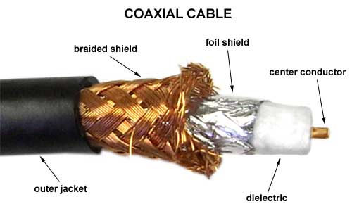This phenomenon is used to protect electronic equipment from electrostatic discharges of external electric fields.

This kind of protection called as a Faraday cage. For example the coaxial cable is a Faraday cage.

**Insulator in the electric field**



When an insulator is placed in an electric field, the atoms and molecules that compose the insulator become polarized and a bound surface charge density in induced. This polarization charge produces an electric field directed opposite the external field, so the external electric field is reduced.

So, inside of insulator the electric field (Einsulator) is opposite direction than external electric field, but smaller. The **net electric field** (E) is same direction with external electric field (Eexternal).

Ratio between those electric fields is a relative permittivity: 

**Dielectric strength**

Dielectric strength Emax means the maximum electric field that a material can withstand without breaking down.

At breakdown, the electric field frees bound electrons.

Air (or any other medium) becomes electrically conducting when the electric field exceeds Emax.

|  |  |
| --- | --- |
| **Substance** | **Dielectric Strength (MV/m)** |
| Air | 3 |
| Window glass | 9,8 - 13,8 |
| Silicone oil, Mineral oil | 10 - 15 |
| PVC | 25 |
| Distilled Water | 65 - 70 |
| Paper (dry) | 20-30 |
| Waxed paper | 40 - 60 |
| Teflon | 30 |

**CAPACITORS**

A capacitor is used to store energy electrostatically in an electric field. The charge of capacitor can be released for further use.

Capacitor consists of two isolated conductors with equal and opposite charges. Its capacitance C is defined:

 

The farad is a very great unit, typical capacitance values range from about 1 pF (10−12 F) to about 1 mF (10−3 F).

**Parallel-plate capacitor**



Parallel-plate capacitor consists of two parallel conducting plates of area **A** separated by a distance **d**.

Between the plates there is an insulator with permittivity of **ε**.



**Cylindrical capacitor**

= Two conducting cylinders of radii r1 and r2 with an insulator between.



**Capacitors in series and parallel**

Two simple arrangements correspond to the elements being connected in series and in parallel. The equivalent capacitance of combination of capacitors **(C)** is the capacitance of a single capacitor which, when used in place of the combination, provides the same external effect.

**Capacitors in series**







For any number of capacitors in series, each has the same charge! The charge of combination is the same as the charge of individual capacitor! The net charge of capacitor is zero! (+Q + (-Q) = 0)

**Capacitors in parallel**







The potential difference (voltage) across circuits elements arranged in parallel is the same.

**Electric energy stored in a capacitor**



When capacitor is charged, the voltage and the charge of capacitor are directly proportional. The energy of a capacitor is the potential energy of the charges on capacitor plates:



The electric field between the plates cannot be over the dielectric strength **Emax** of an insulator.

The potential difference that can be applied between the plates **Umax** called the breakdown potential. If this value exceeded, the dielectric material of insulator will break down and form a conducting path between the plates.